Jedox AI engine empowers finance teams
at Mitsui Chemicals and ServiceMaster

Freiburg & Boston, 18th of July 2019 - Jedox, a leading international software provider for planning and enterprise performance management (EPM), enables finance and other business functions to easily employ predictive analytics and artificial intelligence to gain deeper insight from large data sets. Jedox customers Mitsui Chemicals Europe and ServiceMaster have achieved tangible results in pilot projects to improve sales forecasting and customer loyalty with the new integrated AI engine after just a few months and aim to expand their AI applications.

Automated sales forecast at Mitsui
Mitsui Chemicals Europe GmbH upgraded its existing Jedox planning environment with the Jedox Predictive Analytics and AI Engine. The focus of the project was sales forecasting. To achieve even greater predictive accuracy, the project team and Jedox Partner HighCoordination implemented Jedox's "Predictive Forecast" standard model. Based on the Jedox AIssisted ™ Planning solution, which incorporates pre-built business logic, the 12-month rolling sales forecast is supported by AI-generated sales predictions. After only a few months, the accuracy of the forecast has increased up to 95 percent in relation to the actual values ​​for several product groups. FP&A management at Mitsui sees a high level of potential for automation as a key advantage, especially in terms of the transparency and granularity of the forecast:

"With Jedox AIssisted™ Planning, we can plan at a level of detail that was not possible before. With the AI engine, we can achieve very accurate forecast values and also see a lot of potential for further optimization and automation” said Sascha Geng, Director of Performance Controlling at Mitsui Chemicals Europe.

New insights in customer loyalty at ServiceMaster
ServiceMaster, a Fortune 1000 company headquartered in Memphis, Tennessee, has been using Jedox for internal and external reporting for over three years. To better assess customer loyalty for its Terminix brand, ServiceMaster carried out a pilot project with the Jedox AI engine. The objective was to predict the loyalty of more than 2 million customers to the Terminix brand and to derive appropriate measures to prevent dismissals and increase customer loyalty. To lay the foundation, a massive database of customer contracts was built in Jedox. ServiceMaster was impressed by the speed with which new findings could be generated. The project team also benefited from easy access to the AI-technology for finance, which did not require any special IT or data science skills.

"With faster predictions we can utilize the results that much quicker to determine any changes to our business processes, make those changes, and begin to see results even faster yet." Confirms ServiceMaster's FP&A manager Jamie Cousin.

"In our projects, we often hear that FP&A and other business line managers are very interested in AI, but still consider it futuristic. Our clients are proving that controlling, sales and other departments can already benefit from market-ready AI solutions and can gain a tangible competitive advantage. " adds Dr. Rolf Gegenmantel, Chief Marketing & Product Officer at Jedox.

3.246 characters (incl. free spaces)

Links:
Case Study Mitsui Chemicals Europe: https://www.jedox.com/en/resources/mitsui/
Case Study ServiceMaster: https://www.jedox.com/en/resources/servicemaster/
More information about the Jedox AI engine: https://www.jedox.com/en/epm-software/aissisted-planning/

File service:

All text files and image files are available free of charge in printable quality, please ask for them at presse@u3marketing.com

File 1: Logo Mitsui Cemicals

File 2: Logo Service Master
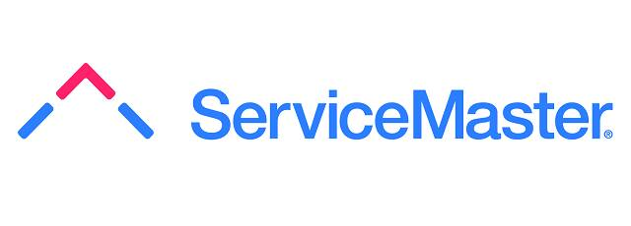

File 3: AIssisted™ Predictive Forecast Dashboard

About Jedox
Jedox simplifies planning, analysis, and reporting with one unified and cloud-based software suite. Jedox empowers decision makers and business users across all departments, helping them work smarter, streamline business collaboration, and make insight-based decisions with confidence. Around 2,500 organizations in over 140 countries use Jedox for real-time planning in the cloud, on the web, and on any device. Founded in 2002, Jedox is a leading provider of Enterprise Performance Management software that incorporates business intelligence in one integrated solution. Locations on four continents and a worldwide network of over 250 business partners underline Jedox’s international orientation. Independent analysts recognize Jedox for its leading enterprise planning solutions.

Contact:

Jedox AG U3 marketing Mainz
Bismarckallee 7a Kästrich 10
79098 Freiburg im Breisgau 55116 Mainz
Germany Germany

Public Relations Press Service
T: +49 761 15147 – 0 T: +49 6131 1433314
E: media@jedox.com E: presse@u3marketing.com

