The Planning Survey 19: Customer Testimonials Confirm Jedox Delivers Outstanding Customer Value and User Experience
Boston/Freiburg May 23, 2019 – Jedox, a leading vendor of Enterprise Performance Management software, achieved outstanding results in this year’s The Planning Survey 19 – the world’s largest customer survey on planning, budgeting and forecasting software. Among EPM tools, Jedox confirmed its top rank with a total of 46 leading positions across its three comparison groups, including 15 top positions in categories such as “Business Value”, “Functionality”, “Data Integration”, “Self-Service” and “User Experience”. The vendor’s impressive 96% product satisfaction rate speaks for itself. With the top rank in Forecasting functionality in the group “BI-Focused Products” and innovative product features, Jedox also solidifies its place as a trailblazer in technology for planning and predictive analytics.
Focus on Customer Value and User Experience
Top rankings in customer-focused categories confirm that Jedox consistently generates customer value. A core KPI for customer value is “Business Value” which consists of “Business Benefits”, “Project Success” and “Project Length”. Jedox regularly achieves top results in this category across its peer groups and again leads the “BI-focused Products” group this year. A second indicator of the software’s customer orientation also stands out: Jedox placed first in two peer groups for “User Experience”, a KPI comprised of “Performance Satisfaction”, “Ease of Use”, “Flexibility” and “Self-Service”.

Financial Self-Service and Comprehensive EPM Functionality

Jedox is well-known for its self-service applications, and finance and FP&A users highly appreciate the market-leading integration within the native Excel environment. Thanks to the Jedox Cloud, it has become even easier and faster to deploy self-service planning and performance management applications for finance and business functions across the enterprise. Agreeing, users rated Jedox as the leader in the “Self-Service” category across two peer groups.
As an integrated software platform for planning, analytics and reporting, Jedox provides comprehensive functionality in all three areas. The software received excellent ratings specifically for its planning, budgeting and forecasting functionality as well as ad-hoc analytics, reporting and dashboarding. Moreover, the platform can be seamlessly integrated with other enterprise data sources resulting in the top rank for “Data Integration” in the peer group “BI-focused products”. Jedox offers its own powerful integration tool for cloud and on-premises data sources as well as an SAP connector for SAP ERP, BW and HANA.

Flexible Forecasting and New Predictive Analytics

Thanks to its powerful technology, Jedox was able to secure the leading positions in “Forecasting” in its peer groups confirming that users are highly satisfied with Jedox’s forecast functionality. In addition, Jedox already offers the next generation of forecasting technology powered by predictive analytics and artificial intelligence: The new integrated AIssisted™ Planning engine for smart Enterprise Performance Management supports automated forecasts and driver-based optimizations with intelligent algorithms.

Strong Customer Benefits
Dr. Christian Fuchs, Senior Vice-President and Head of Analytics & Data Management Practice at BARC, summarizes the results, “Jedox again achieves a great set of results in this year’s Planning Survey. Convincing ratings in numerous important KPIs help to reinforce its position as a market-leading planning and CPM vendor. Companies can benefit from using Jedox’s software in terms of improved employee satisfaction, improved integration of planning with reporting/analysis and reduced resource requirements for planning.”
3,815 characters incl. free spaces

Discover all Jedox Highlights in the Planning Survey 19:
https://www.jedox.com/en/resources/barc-planning-survey-2019/

About The Planning Survey 19

The Planning Survey 19 is based on findings from the world’s largest and most comprehensive survey of planning software users, conducted from November 2018 to February 2019. In total, 1,367 people responded to the survey. Altogether, 22 leading planning software products (or groups of products) were analyzed in detail. The Planning Survey 19 examines user feedback on the selection and usage of planning products across 28 criteria (KPIs).
For more information on the survey, visit www.bi-survey.com.

About Jedox

Jedox simplifies planning, analysis, and reporting with one unified and cloud-based software suite. Jedox empowers decision makers and business users across all departments, helping them work smarter, streamline business collaboration, and make insight-based decisions with confidence. Around 2,500 organizations in over 140 countries use Jedox for real-time planning in the cloud, on the web, and on any device. Founded in 2002, Jedox is a leading provider of Enterprise Performance Management software that incorporates business intelligence in one integrated solution. Locations on four continents and a worldwide network of over 250 business partners underline Jedox’s international orientation. Independent analysts recognize Jedox for its leading enterprise planning solutions.

File Service:
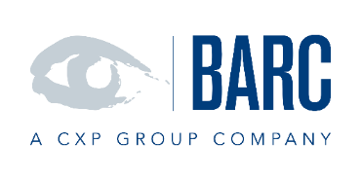

File 1: BARC - logo

File 2: BARC Planning Survey 2019 – logo

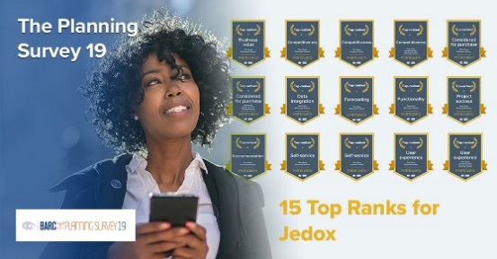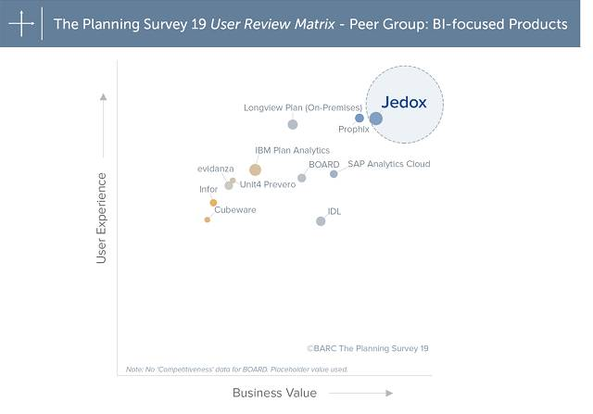

File 3 + 4: Jedox - Top Ranks at BARC Planning Survey 2019

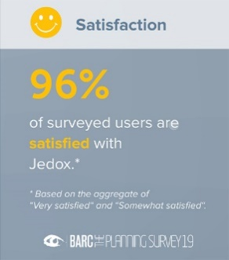

File 5: Jedox – Top Quote for Satisfaction at BARC Planning Survey 2019

